Regulatory Committee
Meeting to be held on 10 March 2021

Part I

Electoral Division affected:
Rossendale West

Wildlife and Countryside Act 1981
Definitive Map Modification Order Investigation
Addition of Footpath from Warburton Street to Grane Road, Haslingden
(Annex ‘A’ refers)

Contact for further information, quoting file no. 804-658:
Simon Moore, 01772 531280, Paralegal Officer, County Secretary and Solicitors Group, Simon.Moore@lancashire.gov.uk
Jayne Elliott, 01772 537663, Public Rights of Way Definitive Map Officer, Planning and Environment Group, jayne.elliott@lancashire.gov.uk

Executive Summary

Application for the addition to the Definitive Map and Statement of Public Rights of Way of a Footpath from Warburton Street to Grane Road, Haslingden.

Recommendation

That the application for the addition of a Footpath from Warburton Street to

Grane Road, Haslingden be accepted.

That an Order be made pursuant to Section 53 (2)(b) and Section 53 (3)(b)

and Section 53 (3)(c)(i) of the Wildlife and Countryside Act 1981 to add a Footpath from Warburton Street to Grane Road on the Definitive Map and Statement of Public Rights of Way as shown on the Committee Plan between points A-B-C.

That being satisfied that the higher test for confirmation can be met the Order

be promoted to confirmation.

Background

An application under Schedule 14 of the Wildlife and Countryside Act 1981 has been received for the addition to the Definitive Map and Statement of Public Rights of Way of a Footpath from Warburton Street to Grane Road, Haslingden.

The county council is required by law to investigate the evidence and make a decision based on that evidence as to whether a public right of way exists, and if so its status. Section 53(3)(b) and (c) of the Wildlife and Countryside Act 1981 set out the tests that need to be met when reaching a decision; also current Case Law needs to be applied.

An order will only be made to add a public right of way to the Definitive Map and Statement if the evidence shows that:
- A right of way “subsists” or is “reasonably alleged to subsist”

An order for adding a way to or upgrading a way shown on the Definitive Map and Statement will be made if the evidence shows that:
- “the expiration… of any period such that the enjoyment by the public…raises a presumption that the way has been dedicated as a public path or restricted byway”

When considering evidence, if it is shown that a highway existed then highway rights continue to exist (“once a highway, always a highway”) even if a route has since become disused or obstructed unless a legal order stopping up or diverting the rights has been made. Section 53 of the Wildlife and Countryside Act 1981 makes it clear that considerations such as suitability, the security of properties and the wishes of adjacent landowners cannot be considered. The Planning Inspectorate’s website also gives guidance about the interpretation of evidence.

The county council’s decision will be based on the interpretation of the evidence discovered by officers and documents and other evidence supplied by the applicant, landowners, consultees and other interested parties produced to the county council before the date of the decision. Each piece of evidence will be tested and the evidence overall weighed on the balance of probabilities. It is possible that the council’s decision may be different from the status given in any original application. The decision may be that the routes have public rights as a footpath, bridleway, restricted byway or byway open to all traffic, or that no such right of way exists. The decision may also be that the routes to be added or deleted vary in length or location from those that were originally considered.

Consultations

Rossendale Borough Council

Rossendale Borough Council provided no response when consulted.

Applicant/Landowners/Supporters/Objectors

The evidence submitted by the applicant/landowners/supporters/objectors and observations on those comments are included in Advice – Head of Service – Legal and Democratic Services Observations.

Advice

Head of Service – Planning and Environment

Points annotated on the attached Committee plan.

Point | Grid Reference (SD) | Description
A | 7788 2243 | Open junction with Warburton Street
B | 7794 2244 | End of bounded route adjacent to 24 Warburton Buildings
C | 7796 2249 | Junction with Grane Road

Description of Route

A site inspection was carried out in October 2020.

The application route commences at the southern end of Warburton Street at its junction with Musbury View. It leaves Warburton Street at Point A on the Committee plan to run in an east north easterly direction along the front the terraced properties numbered 6 – 24 Warburton Buildings for approximately 50 metres to point B. The route is approximately 1.5 metres wide and is bounded on both sides by stone walls with a continuous wall along the south side and a discontinuous wall providing individual access to the front of the properties numbered evenly as 6 – 24 Warburton Buildings on the north side.

Between point A and point B the application route is tarmacked with two street lights located along it.

The route passes through a gap adjacent to 24 Warburton Buildings at point B. This gap had metal security fencing across it when the route was inspected in 2020 but the fencing appeared to have been moved so that it was possible to squeeze through it to continue along the route.

Beyond point B the application route continues in a north easterly direction along the eastern edge of the car park of a former Cantonese restaurant (now closed).

It runs for approximately 50 metres along the edge of the carpark in a straight line to Grane Road (point C). Moss and grass had started to grow on the tarmac along the route but it was otherwise available and there were traces of markings in the tarmac which may have possibly marked the route as separate from the parking area in the past.

At point C a 2 metre wide gap existed between the wall bounding the former carpark and the remains of a wall and planted area. A section of metal security fencing had been placed across the gap at point C which extended along the site to the corner of the former restaurant building (240 Grane Road) including blocking the vehicular access to the former car park – which was separate to the access point at point C.

A sign on the car park states that the car park was for the use of Valley Cantonese customers only and that wheel clamping was in operation. It made no reference to the application route and no other signs existed indicating whether the route was considered to be public or private.

The total length of the route is 100 metres.

Map and Documentary Evidence

A variety of maps, plans and other documents were examined to discover when the route came into being, and to try to determine what its status may be.

Document Title | Date | Brief Description of Document & Nature of Evidence
Yates’ Map  of Lancashire | 1786 | Small scale commercial map. Such maps were on sale to the public and hence to be of use to their customers the routes shown had to be available for the public to use. However, they were privately produced without a known system of consultation or checking. Limitations of scale also limited the routes that could be shown.
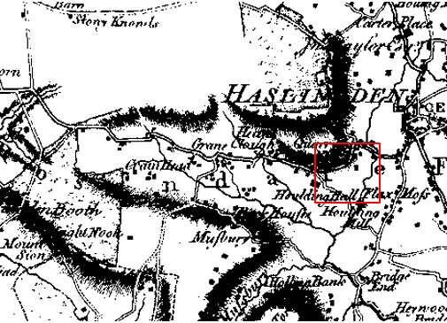
Observations |  | The application route is not shown. The later development either side of the application route is not shown.
Investigating Officer's Comments |  | The application route probably did not exist at this time although if it did exist it would have been very unlikely for a route considered to be a footpath to be shown on such a small scale map.
Greenwood’s Map of Lancashire | 1818 | Small scale commercial map. In contrast to other map makers of the era Greenwood stated in the legend that this map showed private as well as public roads and the two were not differentiated between within the key panel.
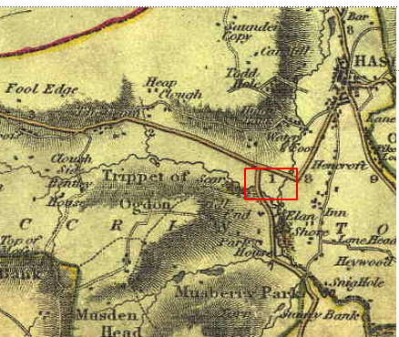
Observations |  | The application route is not shown. Grane Road is shown but the houses (Warburton buildings) and Warburton Street are not shown.
Investigating Officer's Comments |  | The application route probably did not exist in 1818.
Hennet's Map of Lancashire | 1830 | Small scale commercial map. In 1830 Henry Teesdale of London published George Hennet's Map of Lancashire surveyed in 1828-1829 at a scale of 71/2 inches to 1 mile. Hennet's finer hachuring was no more successful than Greenwood's in portraying Lancashire's hills and valleys but his mapping of the county's communications network was generally considered to be the clearest and most helpful that had yet been achieved.
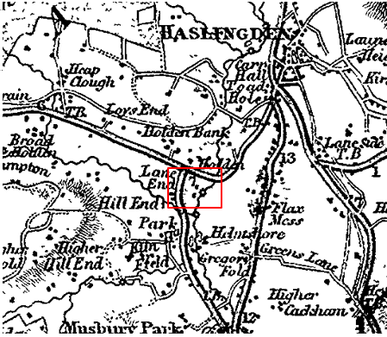
Observations |  | The application route is not shown and the later development on either side of the route is not shown. Some buildings may have existed on the land crossed by the application route but the scale of the map means that it is not possible to determine whether any part of the application route existed.
Investigating Officer's Comments |  | The application route probably did not exist in 1830 because although such a path would be unlikely to be shown, the pattern of buildings which matches the line of the application route did not exist.
Canal and Railway Acts |  | Canals and railways were the vital infrastructure for a modernising economy and hence, like motorways and high speed rail links today, legislation enabled these to be built by compulsion where agreement couldn't be reached. It was important to get the details right by making provision for any public rights of way to avoid objections but not to provide expensive crossings unless they really were public rights of way. This information is also often available for proposed canals and railways which were never built.
Observations |  | The land crossed by the application route was not affected by any existing or proposed canals. The East Lancashire Railway was built to the east of the route in the late 1840s and was in existence until the 1960s but did not cross the land affected by the application.
Investigating Officer's Comments |  | No inference can be drawn with regards to the existence of public rights.
Tithe Map and Tithe Award or Apportionment |  | Maps and other documents were produced under the Tithe Commutation Act of 1836 to record land capable of producing a crop and what each landowner should pay in lieu of tithes to the church. The maps are usually detailed large scale maps of a parish and while they were not produced specifically to show roads or public rights of way, the maps do show roads quite accurately and can provide useful supporting evidence (in conjunction with the written tithe award) and additional information from which the status of ways may be inferred.
Observations |  | There is no Tithe Map available to view in the County Records Office for the area crossed by the application route.
Investigating Officer's Comments |  | No inference can be drawn with regards to the existence of public rights.
Inclosure Act Award and Maps |  | Inclosure Awards are legal documents made under private acts of Parliament or general acts (post 1801) for reforming medieval farming practices, and also enabled new rights of way layouts in a parish to be made. They can provide conclusive evidence of status.
Observations |  | There is no Inclosure Award available to view at the County Records office for the area crossed by the application route.
Investigating Officer's Comments |  | No inference can be drawn with regards to the existence of public rights.
6 Inch Ordnance Survey (OS) Map  Sheet 71 | 1849 | The earliest Ordnance Survey 6 inch map for this area surveyed in 1844-1845 and published in 1849.
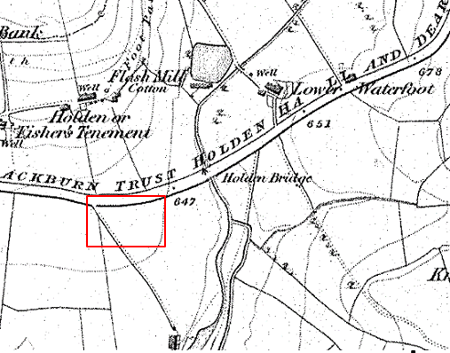
Observations |  | The application route is not shown. Warburton buildings and Warburton Street are not shown and the land crossed by the application route is undeveloped.
Investigating Officer's Comments |  | The application route did not exist in 1844-45.
25 Inch OS Map  Sheets 71-12 and 71-16 | 1893 | The earliest OS map at a scale of 25 inch to the mile. Surveyed in 1891 and published in 1893.
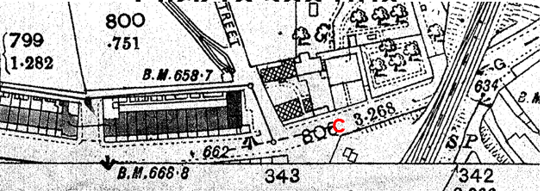
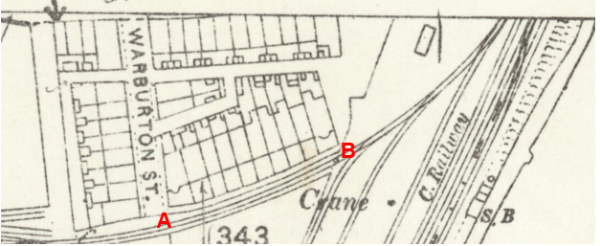
Observations |  | Significant changes had taken place since the survey undertaken in 1844-45. Warburton Street had been built and so had the rows of houses now referred to as Warburton Buildings. The application route is shown as a narrow bounded route from point A to point B between the properties and a railway branch line. Access onto it appears to be open and unrestricted at point A and point B. The application route between point B and point C is not shown. Access from point B appears to be available to an area of open land to the east of the rows of houses with open access onto Grane Road – indicated by pecked lines at point C.  The East Lancashire Railway Clifton Junction to Accrington line is shown to the east of the application route with a boundary wall extending from immediately east of point B to point C which 'kinked' just beyond point B to cross the application route.
Investigating Officer's Comments |  | The application route between point A and point B existed in 1891 and appeared capable of being used. Between point B to point C a route may have been available across an open area of land but it would not have been along the application route. Access onto Grane Road was shown open and unrestricted.
25 inch OS Map  Sheet 71-12 and 71-16 | 1911 | Further edition of the 25 inch map surveyed in 1892, revised in 1909 and published in 1911.
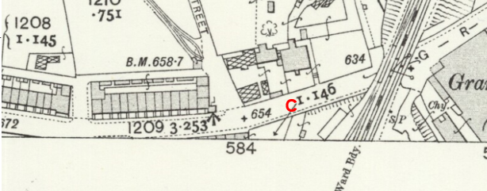
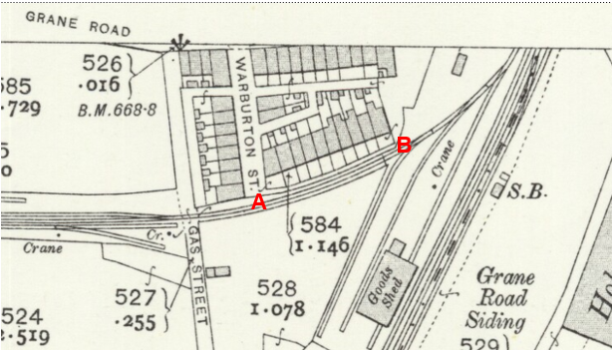
Observations |  | The application route is shown in the same way as it is shown on the First Edition 25 inch OS map between point A and point B. Between point B and point C the route is not shown but access appears to be available across and open area of land. A line is shown across the route at point C suggesting that the land was now bounded along the side of Grane Road and north east of point B the wall protrudes out across the line of the application route.
Investigating Officer's Comments |  | The application route between point A and point B existed in 1909 and appeared capable of being used. Between point B to point C a route may have been available across an open area of land but not along the application route and there is no indication that access would have been available onto Grane Road at point C.
Finance Act 1910 Map | 1910 | The comprehensive survey carried out for the Finance Act 1910, later repealed, was for the purposes of land valuation not recording public rights of way but can often provide very good evidence. Making a false claim for a deduction was an offence although a deduction did not have to be claimed so although there was a financial incentive a public right of way did not have to be admitted.  Maps, valuation books and field books produced under the requirements of the 1910 Finance Act have been examined. The Act required all land in private ownership to be recorded so that it could be valued and the owner taxed on any incremental value if the land was subsequently sold. The maps show land divided into parcels on which tax was levied, and accompanying valuation books provide details of the value of each parcel of land, along with the name of the owner and tenant (where applicable).  An owner of land could claim a reduction in tax if his land was crossed by a public right of way and this can be found in the relevant valuation book. However, the exact route of the right of way was not recorded in the book or on the accompanying map. Where only one path was shown by the Ordnance Survey through the landholding, it is likely that the path shown is the one referred to, but we cannot be certain. In the case where many paths are shown, it is not possible to know which path or paths the valuation book entry refers to. It should also be noted that if no reduction was claimed this does not necessarily mean that no right of way existed.
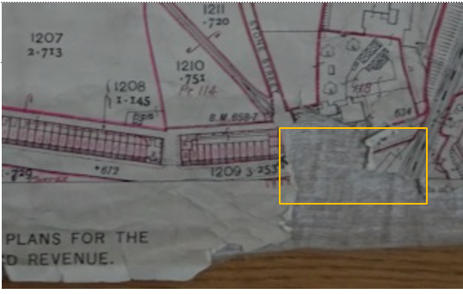
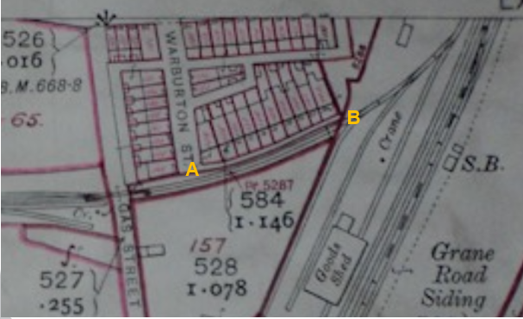
Observations |  | The application route between point A and point B is excluded from the numbered plots. Beyond point B the route is largely included in a numbered plot but even when enlarging the map it was not possible to read the number. The map sheet showing the land crossed by the application route where it exits onto Grane Road at point C was badly damaged and it is not possible to see what was originally drawn.
Investigating Officer's Comments |  | The fact that the application route is excluded between point A and point B is suggestive of, but not conclusive of, public carriageway rights although the physical width would have restricted any vehicles to narrow ones such as handcarts and bicycles. The fact that it was excluded however, and the fact that the route provided direct access to the front of 10 individual properties and that ownership is unregistered (and unknown) is suggestive of a route considered to be a public route.  No inference can be drawn with regards to the existence of public rights between point B and point C as the application route was not excluded and the poor quality of the maps examined means that it is not possible to check any information recorded in the District Valuation Book.
25 Inch OS Map  Sheets 71-12 and 71-16 | 1930 | Further edition of 25 inch map (surveyed 1891, revised in 1928 and published in 1930.

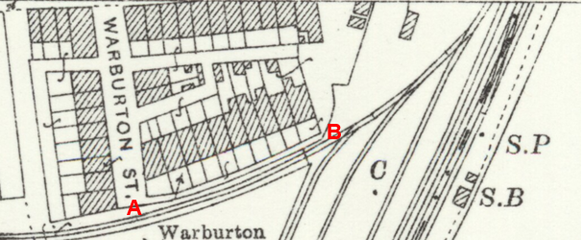
Observations |  | The application route is again shown between point A and point B with open access at both ends. Between point B and point C the application route is not shown and the boundary line shown on earlier editions of the map is still shown extending out across the route together with two buildings that are now shown built on the route approaching point C. Access onto Grane Road at point C is still open and accessible and it appears possible to get from point B to point C but on a different (undefined route) to the west of the application route.
Investigating Officer's Comments |  | The application route existed between point A and point B in 1928. Access may have been available between point B and point C – but not along the line applied for.
Authentic Map Directory of South Lancashire by Geographia | Circa1934 | An independently produced A-Z atlas of Central and South Lancashire published to meet the demand for such a large-scale, detailed street map in the area. The Atlas consisted of a large scale coloured street plan of South Lancashire and included a complete index to streets which includes every 'thoroughfare' named on the map.  The introduction to the atlas states that the publishers gratefully acknowledge the assistance of the various municipal and district surveyors who helped incorporate all new street and trunk roads. The scale selected had enabled them to name 'all but the small, less-important thoroughfares'.
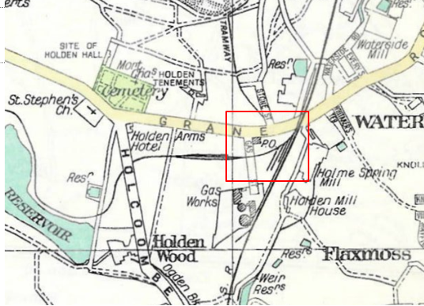
Observations |  | The application route is not shown.
Investigating Officer's Comments |  | No inference can be drawn. It would be unusual for a narrow path to be shown on such a small scale map which was primarily published to show public vehicular routes.
Aerial Photograph | 1940s | The earliest set of aerial photographs available was taken just after the Second World War in the 1940s and can be viewed on GIS. The clarity is generally very variable.
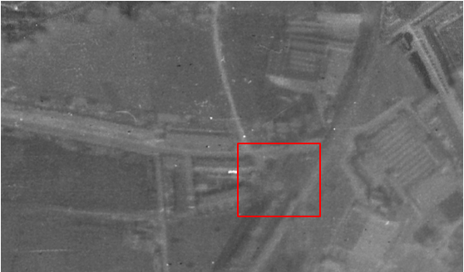
Observations |  | The earliest aerial photograph available to view.  It is just possible to make out the shape of the rows of houses and the railway line but the application route cannot be seen.
Investigating Officer's Comments |  | The application route, if it did exist was not a significant route which showed up on a photograph of this scale.
6 Inch OS Map  Map Sheet 72SE | 1965 | OS 6 inch map revised 1960-61 and published 1965.
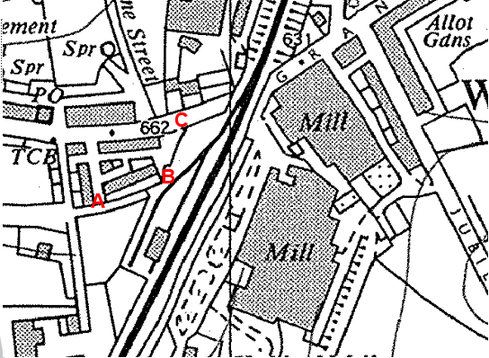
Observations |  | The application route is not shown between point A and point B as a bounded route. A line is shown across the route at point B. The application route is not shown between point B and point C and the same kinked boundary line is shown obstructing the line of the application route. A gap in the line at the roadside is shown at or close to point C.
Investigating Officer's Comments |  | The limitations of scale prevent any inference about section A-B of the route but between point B and point C part is unavailable due to the kink in the wall so the route was not accessible along its full length in the early 1960s.
1:2500 OS Map  Map Sheet SD 7790 2243 | 1962 | Further edition of 25 inch map reconstituted from former county series and revised in 1961 and published in 1962 as national grid series.
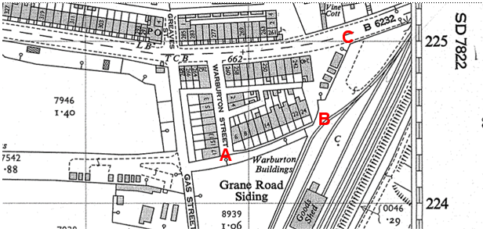
Observations |  | The application route between point A and point B is shown as being open and available. Beyond point B the line of the application route is blocked by the kink in the boundary line and by some buildings. Access onto Grane Road at point C was open.
Investigating Officer's Comments |  | The application route existed between point A and point B in 1961. Access may have been available between point B and point C – but not along the application route itself.
Aerial photograph | 1960s | The black and white aerial photograph taken in the 1960s and available to view on GIS.
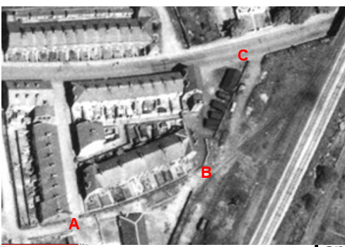
Observations |  | The application route can be seen between point A and point B and appears to extend out into the open area at point B. The application route between point B and point C is not shown and access is not available along the route due to a kink in the wall and a number of buildings which look like sheds or garages. Access from point B around the buildings onto Grane Road appears to have been available.
Investigating Officer's Comments |  | The application route existed between point A and point B. Beyond point B the application route did not exist although access to Grane Road may have been available along a different route.
OS base map | 1980 | OS base map used for Land Registry plan. SD 7722 at a scale of 1:1250 enlarged from 1:2500. Published 1980, date of revision not known.
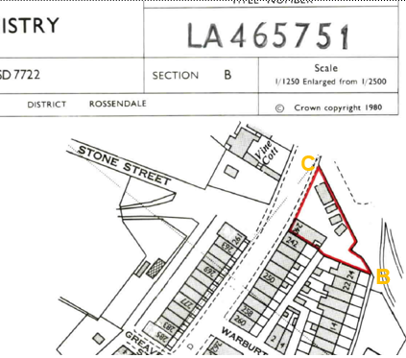
Observations |  | The application route is shown between point A and point B as shown on all earlier editions of OS mapping. Between point B and point C the line of the application route is still shown as being unavailable due to the position of the boundary fence and buildings.
Investigating Officer's Comments |  | The date that the map was surveyed is unknown but it was published in 1980 and was used as the base for a land registry plan prepared in relation to land purchased in 1981 suggesting that the wall line protruding out across the route was correct at that time.  It appears likely that the application route between point B and point C was not available to use at that time.
Aerial Photograph | 2000 | Google Earth Pro image dated 31 December 2000.
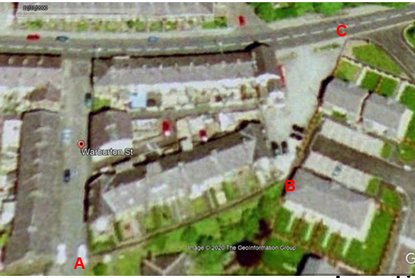
Observations |  | This aerial photograph shows the line of the application route between point A and point B although it is not possible to see whether the route is available and free from any obstructions or restrictions on a photograph like this. Between point B and point C the former wall and buildings across the application route are no longer there and the railway line has been dismantled and the land redeveloped. Two vehicles look to have been parked across the application route but if they were not there it appears that the route would be available to use and access to Grane Road looks to be available at point C.
Investigating Officer's Comments |  | The whole length of the application route appears to have been available in 2000.
Aerial Photograph | 2003 | Google Earth Pro image captured on 16th April 2003.
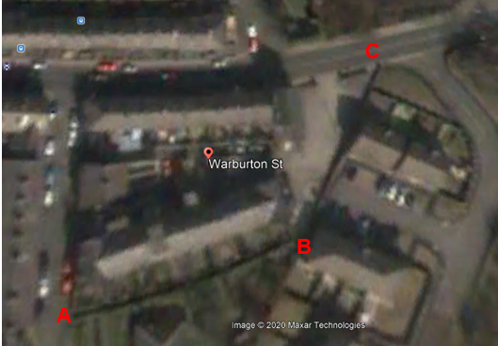
Observations |  | The image is not good quality. A line indicating the application route can be seen between point A and point B but detail of the route cannot be seen. Between point B and point C a route appears to be available and of significance is that an separate access point to the wider (vehicular) access can be seen at point C.
Investigating Officer's Comments |  | The application route appeared to be available to use between point B and point C in 2003. It was not possible to see the enclosed route between point A and point B so no inference can be drawn from the photograph in that regard.
Aerial Photograph | 2005 | Google Earth Pro image captured 31 December 2005.
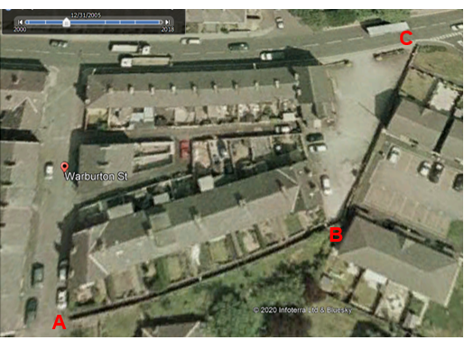
Observations |  | The line of the application route between point A and point B can be seen although it is not possible to see whether the route is available and free from restrictions. Between point B and point C it appears that the route was available to use and access to Grane Road was available at point C.
Investigating Officer's Comments |  | The whole length of the application route appears to have been available in 2005.
Aerial photograph | 2011 | Google Earth Pro Image captured 4th August 2011.
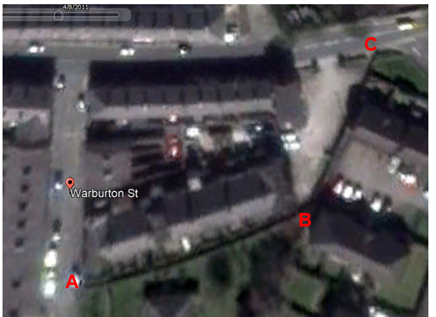
Observations |  | The line of the application route can be seen between point A and point B although because of its width and the fact that it was enclosed by walls it is not possible to see whether access was available or unrestricted. Between point B and point C it appears that the application route was available to use with access onto Grane Road at point C.
Investigating Officer's Comments |  | The whole length of the application route appears to have been available in 2011.
Aerial photograph | 2013 | Google Earth Pro image captured 4th June 2013.
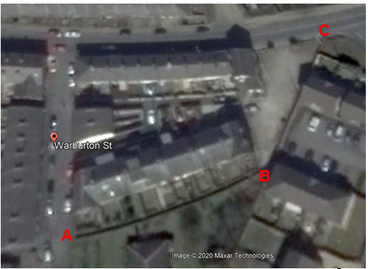
Observations |  | The land crossed by the application route appears unaltered from when the earlier aerial photograph was taken in 2011.
Investigating Officer's Comments |  | The whole length of the application route appears to have been available in 2013.
Aerial Photograph | 2014 | Google Earth Pro image captured 22 April 2014.
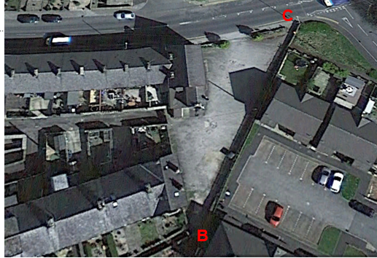
Observations |  | The application route between point A and point B is shown in the same way as it is shown on the earlier Google Earth images. Between point B and point C shadows cast from the adjacent wall and buildings make it difficult to see the route. An object appears to have been placed on the route between point B and point C although it is not possible to determine from this photograph what this was. Google Street view images included later in the report show a commercial refuse bin on two later photographs dated 2017 and 2019 which would be consistent with the shape and size of the object seen here. Access around the object appears to be available and the access onto Grane Road at point C can be clearly seen.
Investigating Officer's Comments |  | Access along the application route appeared to have been available in 2014 with a slight deviation around an unknown object between point B and point C..
Aerial Photograph | 2014 | Aerial photograph available to view on Lancashire County Council mapping.
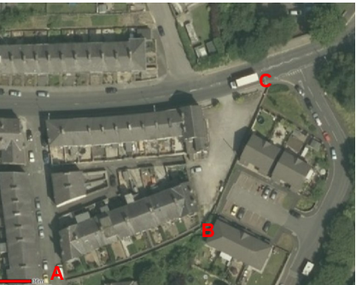
Observations |  | A further aerial photograph taken in 2014 appears to confirm what was shown on the Google Earth Pro image above.
Investigating Officer's Comments |  | Access along the application route appeared to have been available in 2014 with a slight deviation around an unknown object between point B and point C.
Aerial Photograph | 2018 | Google Earth Pro image captured 28th June 2018.
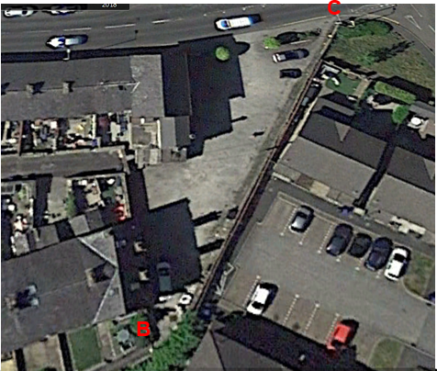
Observations |  | The application route is shown again between point A and point B in a similar manner to all previous images examined. A white mark at point B can be seen but it is unclear what this is and whether it was a gate which may have restricted access. Shadows can be seen across the route between point B and point C but the application route does appear to be largely free of obstruction.
Investigating Officer's Comments |  | Access along the application route appeared to have been available in 2018 with a slight deviation around an unknown object between point B and point C.
Photographs provided by the applicant | 1976-1980 | The applicant provided copies of a number of photographs showing the land crossed by the application route between point B and point C.
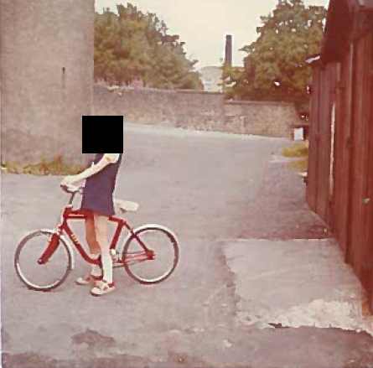
Photograph 1 – described by applicant as showing the rear of 240-242 Grane Road in 1976
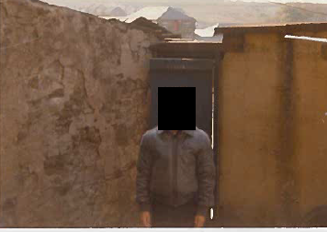
Photograph 2 – Described by applicant as being the rear of 242 Grane Road in 1979
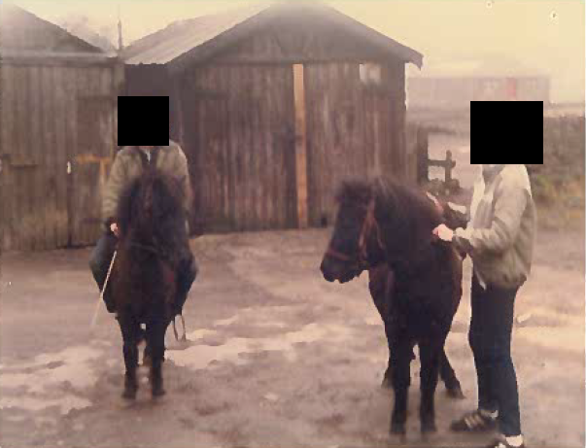
Photograph 3 – Described as being a photograph of access to the old railway siding before Holden Place was built and the words 'open gate wall been altered' dated 1980
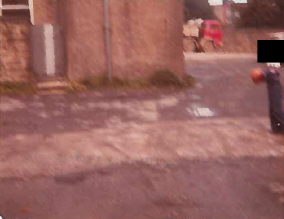
Photograph described by applicant as showing land to the rear of 240 Grane Road and dated 1980
Observations |  | The four photographs submitted by the applicant show the land crossed by the application route between point B and point C. They do not show the exact line of the route as claimed and where taken at a time when the line of the application route between point B and point C did not appear to be available. They show children on the land which became the car park for the Cantonese restaurant but there is no indication whether the use being made of that land was by permission or by right. Wooden garages/sheds are shown along the line of the route between point B and point C (photograph 1 and 3) confirming that in the 1970s until at least 1980 the route claimed between point B and point C was not available to walk on the ground.
Investigating Officer's Comments |  | The application route between point B and point C did not exist in 1976-1980.
Google Street View | 2009-2019 | Series of Google Street View images showing the application route from point C looking back towards point B taken over a 10 year period from 2009 to 2019.
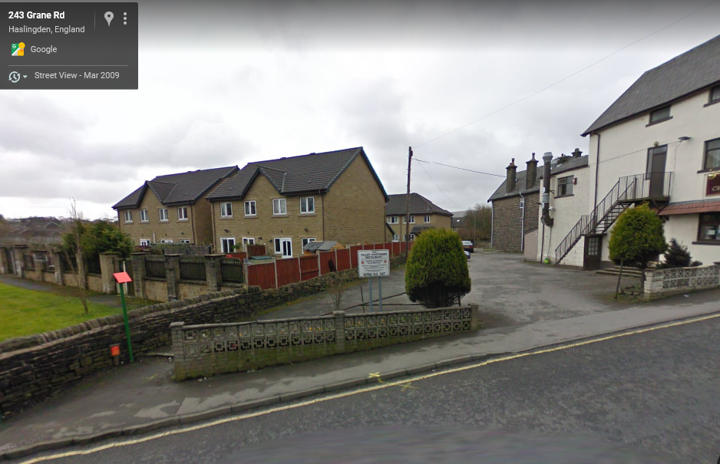
2009
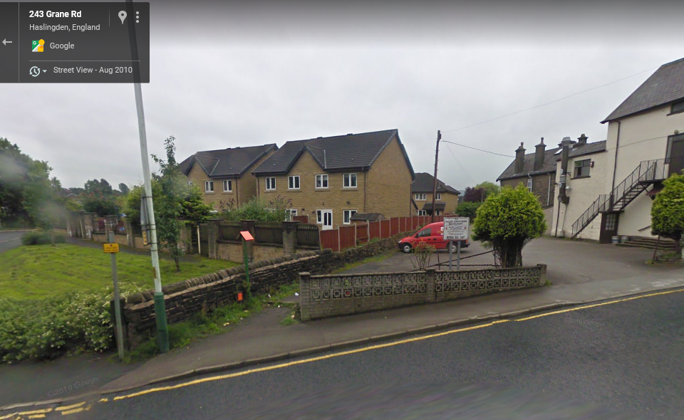
2010
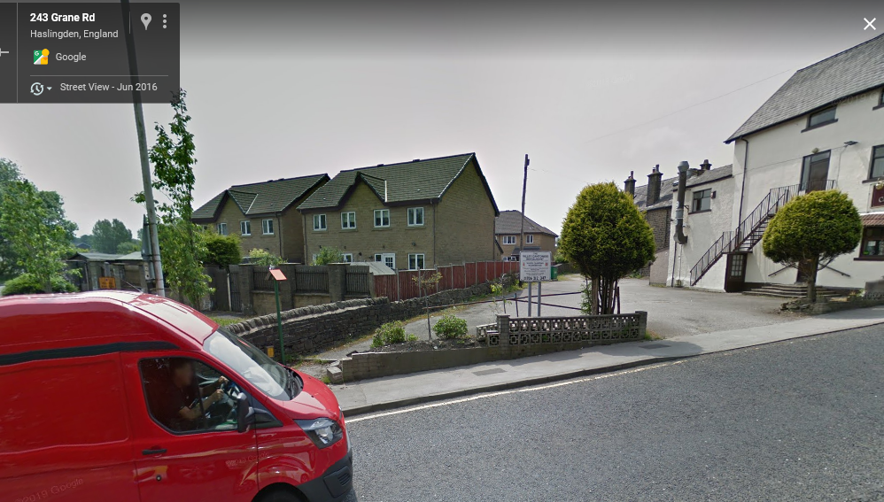
2016
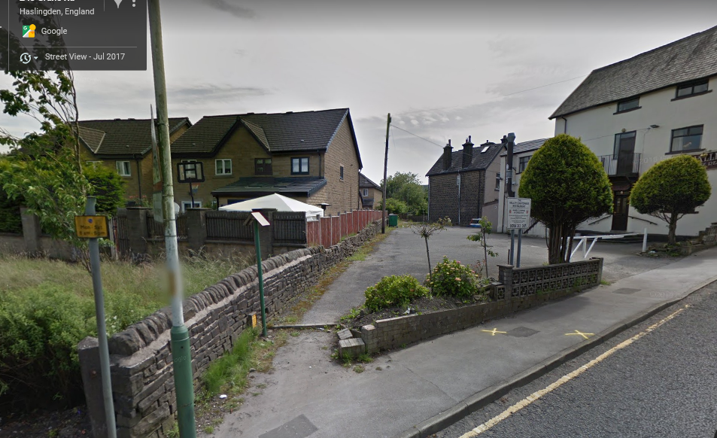
2017
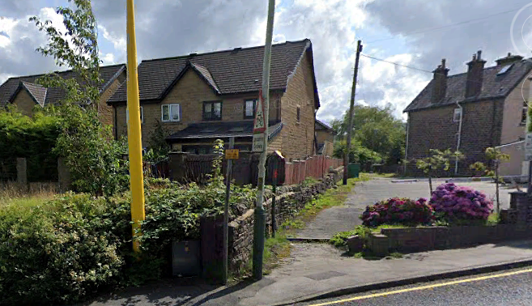
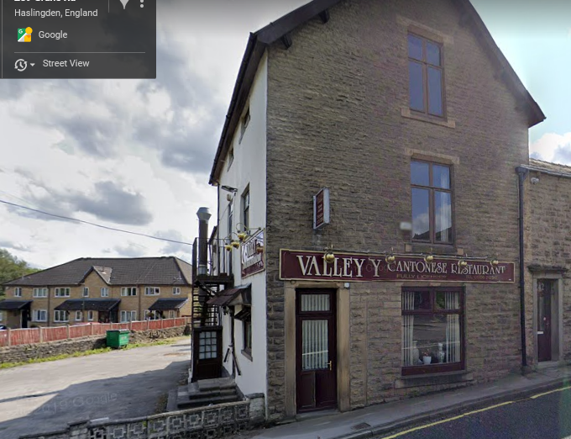
2019
Observations |  | The photographs all show the application route from point C across the car park to point B. A car can be seen parked on the route on the photographs taken in 2009 and 2010 and it appears that a commercial refuse bin was also located on a strip of rough grass hard up against the wall on the route of the application route on the photographs taken in 2017 and 2019.
Investigating Officer's Comments |  | The application route consistently appears to have been available for use over the 10 year period 2009-2019 between point B and point C although it may have been necessary to walk around a refuse bin and the occasional parked car.
Definitive Map Records |  | The National Parks and Access to the Countryside Act 1949 required the County Council to prepare a Definitive Map and Statement of Public Rights of Way.  Records were searched in the Lancashire Records Office to find any correspondence concerning the preparation of the Definitive Map in the early 1950s.
Parish Survey Map | 1950-1952 | The initial survey of public rights of way was carried out by the parish council in those areas formerly comprising a rural district council area and by an urban district or municipal borough council in their respective areas. Following completion of the survey the maps and schedules were submitted to the County Council. In the case of municipal boroughs and urban districts the map and schedule produced, was used, without alteration, as the Draft Map and Statement. In the case of parish council survey maps, the information contained therein was reproduced by the County Council on maps covering the whole of a rural district council area. Survey cards, often containing considerable detail exist for most parishes but not for unparished areas.
Observations |  | The application route is in Haslingden which is a former Municipal Borough for which no parish survey map was prepared.
Draft Map |  | The Draft Maps were given a “relevant date” (1st January 1953) and notice was published that the draft map for Lancashire had been prepared. The draft map was placed on deposit for a minimum period of 4 months on 1st January 1955 for the public, including landowners, to inspect them and report any omissions or other mistakes. Hearings were held into these objections, and recommendations made to accept or reject them on the evidence presented.
Observations |  | The application route was shown on the Draft Map and no representations were made to the County Council.
Provisional Map |  | Once all representations relating to the publication of the draft map were resolved, the amended Draft Map became the Provisional Map which was published in 1960, and was available for 28 days for inspection. At this stage, only landowners, lessees and tenants could apply for amendments to the map, but the public could not. Objections by this stage had to be made to the Crown Court.
Observations |  | The application route was shown on the Provisional Map and no representations were made to the County Council.
The First Definitive Map and Statement |  | The Provisional Map, as amended, was published as the Definitive Map in 1962.
Observations |  | The application route was shown on the First Definitive Map.
Revised Definitive Map of Public Rights of Way (First Review) |  | Legislation required that the Definitive Map be reviewed, and legal changes such as diversion orders, extinguishment orders and creation orders be incorporated into a Definitive Map First Review. On 25th April 1975 (except in small areas of the County) the Revised Definitive Map of Public Rights of Way (First Review) was published with a relevant date of 1st September 1966. No further reviews of the Definitive Map have been carried out. However, since the coming into operation of the Wildlife and Countryside Act 1981, the Definitive Map has been subject to a continuous review process.
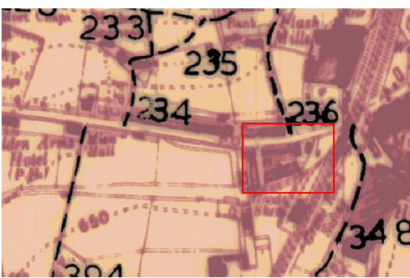
Observations |  | The application route is not shown on the Revised Definitive Map First Review.
Investigating Officer's Comments |  | From 1953 through to 1975 there is no indication that the application route was considered to be a public right of way that should be recorded on the Definitive Map by the Surveying Authority. There were no objections to the fact that the route was not recorded when the maps were placed on deposit for inspection at any stage of the preparation of the Definitive Map.
Highway Adoption Records including maps derived from the '1929 Handover Maps' | 1929 to present day | In 1929 the responsibility for district highways passed from district and borough councils to the County Council. For the purposes of the transfer, public highway 'handover' maps were drawn up to identify all of the public highways within the county. These were based on existing Ordnance Survey maps and edited to mark those routes that were public. However, they suffered from several flaws – most particularly, if a right of way was not surfaced it was often not recorded.  A right of way marked on the map is good evidence but many public highways that existed both before and after the handover are not marked. In addition, the handover maps did not have the benefit of any sort of public consultation or scrutiny which may have picked up mistakes or omissions.  The County Council is now required to maintain, under section 31 of the Highways Act 1980, an up to date List of Streets showing which 'streets' are maintained at the public's expense. Whether a road is maintainable at public expense or not does not determine whether it is a highway or not.
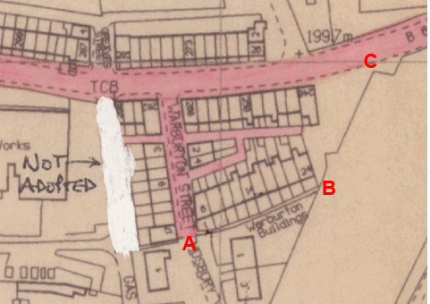

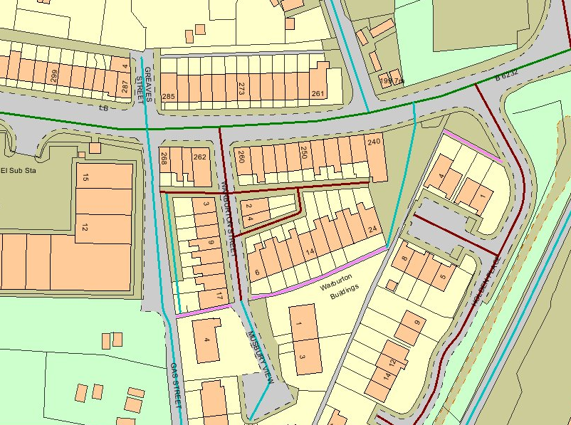
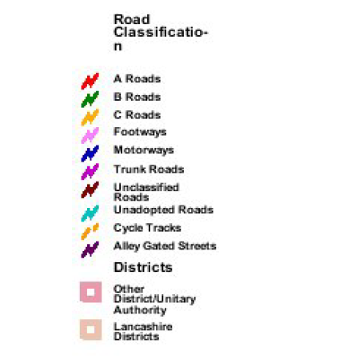
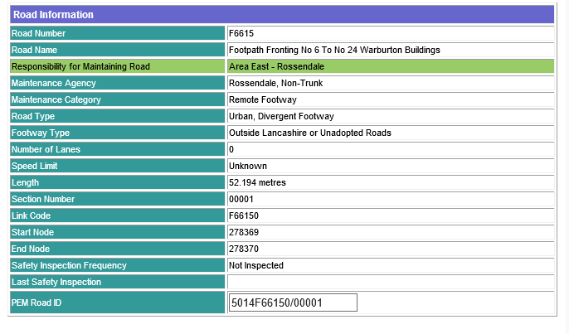
Observations |  | The application route is not recorded as a publicly maintainable highway on the county council's List of Streets.
Investigating Officer's Comments |  | The fact that the route is not recorded as a publicly maintainable highway does not mean that it does not carry public rights of access so no inference can be drawn.
Highway Stopping Up Orders | 1835 - 2014 | Details of diversion and stopping up orders made by the Justices of the Peace and later by the Magistrates Court are held at the County Records Office from 1835 through to the 1960s. Further records held at the County Records Office contain highway orders made by Districts and the County Council since that date.
Observations |  | No legal orders relating to the creation, diversion or extinguishment of public rights have be found.
Investigating Officer's Comments |  | If public rights are found to exist along the application route they do not appear to have been subsequently diverted or extinguished by a legal order.
Statutory deposit and declaration made under section 31(6) Highways Act 1980 |  | The owner of land may at any time deposit with the County Council a map and statement indicating what (if any) ways over the land he admits to having been dedicated as highways. A statutory declaration may then be made by that landowner or by his successors in title within ten years from the date of the deposit (or within ten years from the date on which any previous declaration was last lodged) affording protection to a landowner against a claim being made for a public right of way on the basis of future use (always provided that there is no other evidence of an intention to dedicate a public right of way).  Depositing a map, statement and declaration does not take away any rights which have already been established through past use. However, depositing the documents will immediately fix a point at which any unacknowledged rights are brought into question. The onus will then be on anyone claiming that a right of way exists to demonstrate that it has already been established. Under deemed statutory dedication the 20 year period would thus be counted back from the date of the declaration (or from any earlier act that effectively brought the status of the route into question).
Observations |  | No Highways Act 1980 Section 31(6) deposits have been lodged with the county council for the area over which the route under investigation runs.
Investigating Officer's Comments |  | There is no indication by the landowners under this provision of non-intention to dedicate public rights of way over this land.

The affected land is not designated as access land under the Countryside and Rights of Way Act 2000 and is not registered common land.

Landownership

The length of the application route from 6 to 24 Warburton Buildings (between point A and B on the Committee plan) crosses land which is unregistered, from 24 Warburton Buildings (between point B and point C) the application route crosses land registered under title numbers LA465751 and LA840093.

Summary

The application was submitted primarily on the basis of user evidence pre-dating the obstruction of the route at point B and point C in 2019.

Whilst there is no map and documentary evidence from which dedication of the route can clearly be inferred it is clear that the route from point A through to point B has existed since at least 1891 and that access along it has consistently appeared to be available providing direct access to the houses known as Warburton Buildings but also through point B onto an area of land adjacent to 240 Grane Road from which it appeared that it was possible to exit onto Grane Road – but not necessarily via the application route B-C.

The current registered owner of the land crossed by the application route between point B and point C (with the exception of a small area owned by the Places for People Homes Ltd.) purchased the property in 1981 and it appears that at some point between then and 2000 the site was cleared of the buildings (garages/sheds) that previously existed across the route.

No further dated OS map sheets were found from which it was possible to date the changes.

From 2000 onwards the aerial photography and Google Street View images consistently show that the application route crossed a car park with what appeared to be a dedicated pedestrian access point clearly separate to vehicular access at point C. Despite the occasional car parked across the route and the bins located on it a route, although not adjacent to the wall where the bins stood, appears to have been available between point B and point C approximating to the application route from at least 2000.

Head of Service – Legal and Democratic Services Observations

Information from the Applicant

The Applicant provided the following supporting information:

- A letter of support from Grane Residents' Association.
- A letter of support from the former leader of Grane Youth Group
- A 1986 Youth Group list relating to a trip to Morecambe
- A 1985 Youth Group letter
- Map extracts which have been considered above.
- Historic photographic evidence which has been considered above.
- Modern photographic evidence which has been considered above.
- 14 user evidence forms.

The 14 user evidence forms are summarised below. Of the forms submitted 3 included use by couples for a total of 17 users.

Type of Route

The majority of users stated that they believe the route should be recorded as footpath with only one user varying from this, believing that the route should be recorded as a restricted byway.

The majority of users recorded use of the route on foot only with only one couple recording that they used the route by car on a weekly basis.

Duration of Use

The user evidence forms collectively provide evidence of use going back as far as 1940 and up to 2020. The route appears to have been called into question in 2019 when the route was reportedly blocked but two users, recording their use in a single user evidence form reported continued use of the route in 2020.

Two users recording their evidence in a single user evidence form did not specify the years which they had used the route but stated that they had used it for 45 and 53 years respectively.

One user, having used the route from approximately 1940 to 2019 noted being a tenant of the then landowner in the period 1972-1979.

20+ Years  Including the years (1999 to 2019) | 1-19 Years | Other
13 | 2 | 2

Frequency of Use

The majority of the users stated that they used the route daily with one user stating that they used the route 4 to 6 times per day.

More than once daily | Daily | Weekly
1 | 12 | 4

Reasons for Use

The majority of users specified pleasure and use as an access route as their reasons for using the applications route. 5 users noted using the route to get to work. One user noted dog walking.

Other Users of the Route

All users recorded having seen others using the route on foot. In addition to use on foot 2 users noted seeing others using the route on bicycle, 1 user noted use on bicycle and by horse drawn vehicle and 2 users noted use by motorised vehicles.

Consistency of the Route

All users specified that the application route had always followed the same route, 8 users provided an estimate width with this ranging from 1 to 2 metres.

Permissive Use of the Route

4 users noted having permission to use the route, 2 noted this in relation to having a key to the gates of the carpark. 2 noted that they had received permission from LCC and the owners of the Valley Cantonese restaurant.

Unobstructed Use of the Route

Several users noted obstructions along the route though many did not record any obstruction and only some recorded the obstructions as having prevented them from using the route.

Route Obstructed
Mentioned Barriers | Mentioned Gates | Not Obstructed | Not Specified
6 | 4 | 6 | 1

Of the 6 users who mentioned barriers all noted those erected in 2019 and further recorded that these had prevented continuing use of the route.

Of the 4 users who mentioned gates 2 specified gates leading onto Holcombe Road, 1 noted a gate next to 240 Grane Road, locked at night and otherwise sometimes left open and unlocked. The final user simply stated that the gate was sometimes locked. None of these 4 users noted that the gate had prevented their use of the route.

Of the 17 users 2 noted having been informed recently that the route was not public in conjunction with the erection of barriers.

3 users noted being turned back though this was in relation to finding the route obstructed by the barriers.

Information from Others

The letter of support from the Grane Resident's association states that the route has been in use for over 40 years and that members of the association have used the route since 1991 when delivering newsletters and relevant information.

The letter of support from the former leader of Grane Youth Group noted that the youth group leaders used the route for similar purposes in distributing leaflets and other paperwork. The list relating to a trip to Morecambe and the letter dated 1985 are presented as evidence of this.

Tapestart Limited responded to confirm freehold interest (subject to long leasehold interests) in land adjacent to the application route at Warburton Buildings, they provided no further comment at this stage.

Cadent Gas responded to consultation to state they had no objection.

Atkins Global responded to consultation to state they had no objection.

United Utilities responded to alert the council to a waste water pipe near the application route.

Rossendale Ramblers responded to consultation to state they had no objection and saw the application as a positive development.

Information from the Landowner

One of the affected landowners responded to confirm their landownership and to raise an objection to the application.

The landowner clarified that on purchasing the property in 2019 he understood that the legal rights of crossing the land were fully investigated by their solicitor. It was found that there were no rights reserved over any part of the land and local searches carried out by the solicitor proved no access roads across the land. The landowner went on to state that the openings in the boundary walls around the property are for the benefit of the property 240 to enter and exit through.
The landowner clarified that they had erected the Heras fencing to secure the property and make it a safe work site due to extensive refurbishment work on the property with site traffic likely to cause risk to the public. The landowner noted that there have been cases of fences being moved, cut, fence bases being stolen and CCTV tampered with.

The Landowner also noted problems encountered by the previous landowner who ran a Cantonese restaurant claiming numerous issues with the Warburton Building and Grane Road residents when trying to secure the property from trespassers.

In addition, the landowner noted that the property is currently in the process of a planning application, with a view to accommodate vulnerable people and that the development as planned will not be viable if the application is successful.

The landowner also noted that according to their understanding the reason that some of the residents cross the property is because they park their vehicles on Holden Place. They stated that this has been a contentious issue between the residents of Holden Place and Warburton Buildings and that the residents of Holden Place applied for double yellow lines to be installed and therefore parking in this area will soon not be possible removing the need to cross the land via the application route. In conjunction with this the landowner noted a meeting with Councillor David Stansfield where they explained the situation, discussed the documents and Councillor Stansfield is reported to have concluded that the landowner was correct in their position regarding any access.

The landowner also provided some insight into the development of the area in relation to access along Grane Road and Warburton Street: "Historically the tramline ran along the Southernly point and up across Grane Road. I believe the tramline was open access at the bottom of Warburton Street, as there were various goods shed in the vicinity, and this would ease access to the sheds for the loading of materials such as sandstone flags quarried from Hutch Bank Quarry. Later when the tramline was decommissioned, it was an open field but still open access from the bottom of Warburton Street along the original tram line route. Then when the Holden Place and Musbury View houses were built, any access points linking Warburton Street to Grane Road, other than the main road access, were closed off."

In a further email the landowner provided two map extracts, one the Title Plan for 240 Grane Road (below), the landowner noted the existence of the out buildings/garages and also that within the deeds it is noted that the property is 'bounded by the railway sidings'.

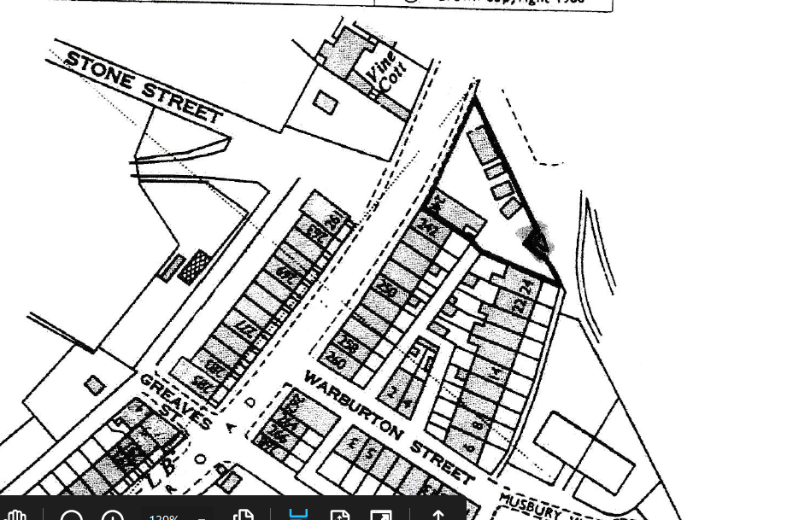

An OS map extract was also provided by the landowner illustrating the out buildings and a further view of the surrounding areas which shows the open land to the East.

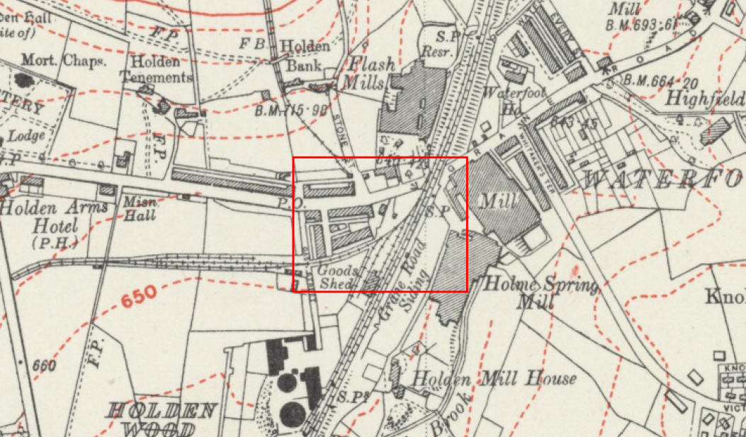

The significance of both maps is included in the analysis of the map and documentary evidence above.

Assessment of the Evidence

The Law - See Annex 'A'

In Support of Making an Order(s)

- User evidence and letters of support.
- Absence of signs and notices along the route stating that the route was not public.
- Absence of action taken by landowners until 2019 to discourage use of the route.
- Aerial Photographs and Google Street View Images from 2000.

Against Making an Order(s)

- Objects, structures and potential car parking between points B and C of the route which may have caused users, at times, to deviate from the application route.

Conclusion

The application is that the route A-B-C has already become a footpath in law and should be recorded on the Definitive Map and Statement of Public Rights of Way.

It is advised that as there is no express dedication in this matter Committee should consider, on balance, whether there is sufficient evidence from which to have dedication inferred at common law from all the circumstances or for the criteria in section 31 Highways Act 1980 for a deemed dedication to be satisfied based on sufficient twenty years "as of right" use to have taken place ending with this use being called into question.

Firstly looking at whether there are circumstances from which dedication could be inferred at common law, Committee is advised to consider whether the evidence presented within this report from the various maps and other documentary evidence coupled with the evidence on site and user evidence, indicates that it can reasonably inferred that in the past the landowner(s) intended to dedicate the route as a public right of way.

The Head of Service – Planning and Environment has considered the historical map and documentary evidence and concluded that, whilst it is clear that the route A-B has existed since at least 1891 and that it would appear that at some point between 1981 and 2000 the route B-C was cleared of buildings that previously existed across the route, there is no map or documentary evidence from which dedication of the route can be clearly inferred.

The Aerial photographs and Google Street View images provide some assistance in relation to the route approximating B-C but only from 2000 onwards.

Therefore, it is suggested that on balance, there is insufficient evidence to infer dedication at common law.

Secondly looking at deemed dedication under section 31 Highways Act 1980, Committee will be aware that in order to satisfy the criteria for s31, there must be sufficient evidence of use of the claimed route by the public, as of right (without force, secrecy or permission) and without interruption, over the 20 year period immediately prior to its status being brought into question, in order to raise a presumption of dedication. The presumption may be rebutted if there is sufficient evidence that there was no intention on the part of the landowner during this period to dedicate the route as a public right of way. In this matter, the evidence indicates that access to the route was obstructed at points B and C in 2019; therefore, the 20 year period under consideration for the purposes of establishing deemed dedication would be 1999-2019.

The applicant has provided 14 user evidence forms in support of the application (3 of which comprise of use by couples), which refer to regular use of the route from as early as 1940. A number of letters have also been provided in support of the application.

All 17 users have provided evidence of use of the application route during the period under consideration. The main purposes stated for use of the route were for pleasure and use as an access route, use of the route to get to work and dog walking. The majority of users stated that they had used the route on foot daily. 4 of the users also expressed that they had used the route weekly, 1 user more than once a day and another 4-6 times per week. One couple refer to having used the route weekly by car however, from the information provided this use would appear to be via the car park area adjacent to no. 240 Grane Road to the rear of their property at no. 242 Grane Road rather than via use of the application route itself.

All users refer to having witnessed others using the route on foot, with 2 users also referring to have witnessed bicycle use, 1 user noting use on bicycle and horse drawn vehicle and 2 users noting use by motorised vehicle.

All of the users state that the application route has always followed the same course.

Several of the users make reference to obstructions along the route. However, none of the users refer to any gates or barriers of relevance that prevented use prior to the route being called into question in 2019. 2 of the users also report use of the route in 2020 despite the erection of the barriers. None of the users refer to having seen signs or notices along the route.

Whilst 2 of the users note having been informed that the route was not public, this was in conjunction with the erection of the barriers in 2019. None of the users recall having ever been told that the route was not a public right of way prior to 2019. Again, whilst 3 of the users refer to having been turned back when using the application route this is in relation to their finding the route obstructed by the 2019 barriers.

Committee will note that 4 of the users referred to having permission to use the route. However, the 2 users (both of the same address) who refer to having had permission from the owners of the Valley Cantonese and LCC as 'owner of the path' provide no further detail in this regard and both stated that they had never been told that the route was not public. With regards to the other 2 users (again, both of the same address) whilst reference is made to permission having been given, this is with reference to access to the car park for the purposes of unloading their car, and not with reference to the application route.

Committee will note that an objection has been received from one of the landowners. However, whilst this objection is acknowledged, it is submitted that the concerns raised are not relevant considerations under either section 31 Highways Act 1980 or under Common Law.

In conclusion, taking all of the evidence into account, Committee on balance may consider that the provisions of section 31 Highways Act 1980 can be satisfied, and Committee is therefore advised to accept the application, make an Order and promote the Order to confirmation.

Risk management

Consideration has been given to the risk management implications associated with this claim. The Committee is advised that the decision taken must be based solely on the evidence contained within the report, and on the guidance contained both in the report and within Annex 'A' included in the Agenda Papers. Provided any decision is taken strictly in accordance with the above then there is no significant risks associated with the decision making process.

Local Government (Access to Information) Act 1985

List of Background Papers

Paper | Date | Contact/Directorate/Tel
All documents on File Ref: 804-658 |  | Simon Moore, 01772 531280, County Secretary and Solicitors Group
Reason for inclusion in Part II, if appropriate

N/A

The Ordnance Survey (OS) has produced topographic maps at different scales (historically one inch to one mile, six inches to one mile and 1:2500 scale which is approximately 25 inches to one mile). Ordnance Survey mapping began in Lancashire in the late 1830s with the 6-inch maps being published in the 1840s. The large scale 25-inch maps which were first published in the 1890s provide good evidence of the position of routes at the time of survey and of the position of buildings and other structures. They generally do not provide evidence of the legal status of routes, and carry a disclaimer that the depiction of a path or track is no evidence of the existence of a public right of way.
Aerial photographs can show the existence of paths and tracks, especially across open areas, and changes to buildings and field boundaries for example. Sometimes it is not possible to enlarge the photos and retain their clarity, and there can also be problems with trees and shadows obscuring relevant features.

